

Campaign Fact Sheet
Prediabetes Awareness

Campaign Sponsors:
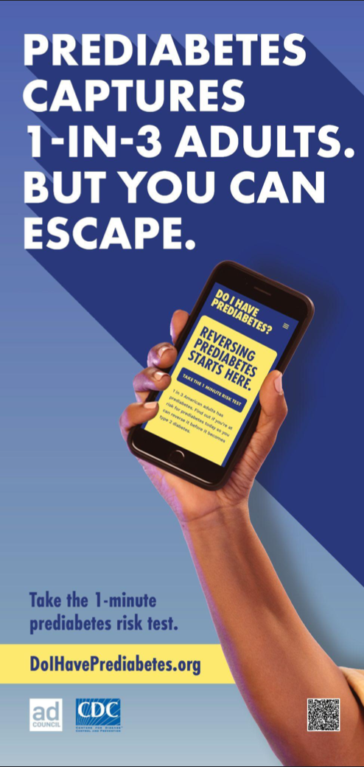
Centers for Disease Control and Prevention (CDC)

Volunteer Advertising Agency:
Avoq

BACKGROUND:
115.2 million Americans (more than 2 in 5 adults) have prediabetes and are at higher risk of developing type 2 diabetes, heart attack, and kidney disease. Of these individuals with prediabetes, 80% of them don’t know they have it. Prediabetes means a person’s blood sugar level is higher than normal, but not yet high enough to be diagnosed as type 2 diabetes.

The good news is that by knowing one’s risk for prediabetes, people can take steps to reverse it and often prevent or delay type 2 diabetes. Making healthy lifestyle changes like increasing physical activity, eating healthier, and managing weight can help reverse prediabetes.

CAMPAIGN OBJECTIVE:
Raise awareness of prediabetes to help people reverse prediabetes and prevent or delay the onset of type 2 diabetes by encouraging audiences to take the 1-minute prediabetes risk test at DoIHavePrediabetes.org
(PodriaTenerPrediabetes.org in Spanish).

TARGET AUDIENCE:
Adults ages 40+ who have prediabetes or are at increased risk of developing type 2 diabetes, with a focus on audiences most at risk.

DID YOU KNOW?

- More than 2 in 5 American adults have prediabetes.

- 80% of people with prediabetes don’t know they have it.

